Study: Wi-Fi Makes Our Trees Sick
By Alex Williams / November 19, 2010 11:24 PM / 1 Comment
Share 25digg

This post is part of our ReadWriteCloud channel, which is dedicated to covering virtualization and cloud computing. The channel is sponsored by Intel and VMware. Read their latest case study: Ausclad Responds to Energy Demands with Virtualization.
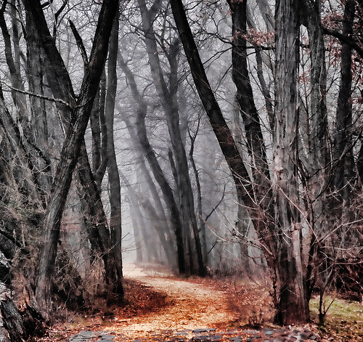Data centers hum day and night. More often than ever before we connect to these cloud environments through Wi-Fi networks.
According to PCWorld, now it looks like the radiation from Wi-Fi networks is making our trees sick, "causing significant variations in growth, as well as bleeding and fissures in the bark."
All deciduous trees in the Western hemisphere are affected by the radiation. The study was conducted by the Wageningen University. The research was ordered by officials from the city of Alphen aan den Rijn who began discovering trees that had a sickness that could not be identified as a virus or bacterial infection.
After further study, it was discovered that the disease occurred throughout the Western world.
Trees in urban areas appear most affected. The study found that 70% of all trees in urban areas show the symptoms, compared to 10% five years ago. Trees in dense forests do not appear to be impacted.
Wireless LAN networks and mobile phone networks may be only partly to blame. Ultrafine particle emissions from cars and trucks may also be responsible.
According to PCWorld:
"The study exposed 20 ash trees to various radiation sources for a period of three months. Trees placed closest to the Wi-Fi radio demonstrated a "lead-like shine" on their leaves that was caused by the dying of the upper and lower epidermis of the leaves. This would eventually result in the death of parts of the leaves. The study also found that Wi-Fi radiation could inhibit the growth of corn cobs."
More research is needed to confirm the results and determine the long-term effects

